|  |  |
| --- | --- |
|  | **Year 11 ATAR Human Biology**  **Task 9 – Assisted Reproductive Technologies** |

|  |  |  |
| --- | --- | --- |
| **Name:** | **Teacher:** | **Date:** |

## Task 10 Assisted Reproductive Technologies

**Marks**

Part A - _____ /7

Part B - _____ /29

Total - ______ /36

%

**Assessment type:** Extended response

**Conditions**

Time for the task:

* **Part A: One lesson to research topic and complete notes at home.**
* Part B: One lesson for in-class validation – includes task related to research in Part A (single sided page of handwritten notes allowed for Part B).

**Task weighting** – 15%

______________________________________________________________________________

**Part A: Research notes (7 marks)**

**Assisted reproductive technologies**

Infertility is the inability to conceive a child or carry a child to birth. About 75 percent of causes of infertility can be identified; these include diseases, such as sexually transmitted diseases that can cause scarring of the reproductive tubes in either men or women, or developmental problems frequently related to abnormal hormone levels in one of the individuals. Inadequate nutrition, especially starvation, can delay menstruation. Stress can also lead to infertility. Short-term stress can affect hormone levels, while long-term stress can delay puberty and cause less frequent menstrual cycles. Other factors that affect fertility include toxins (such as cadmium), tobacco smoking, marijuana use, gonadal injuries, and aging. If infertility is identified, several assisted reproductive technologies (ART) are available to aid conception.

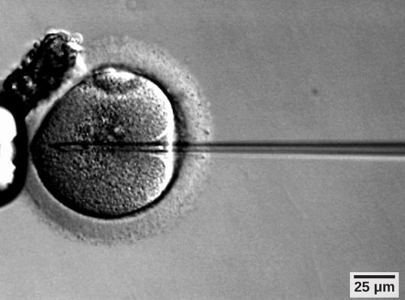

Figure 1. A sperm is inserted into an egg for fertilization during intracytoplasmic sperm injection (ICSI). (credit: scale-bar data from Matt Russell)

(<https://courses.lumenlearning.com/wm-biology2/chapter/infertility/>)

**Research**

Complete a single sided, handwritten page of notes for Part A of this task. In your notes you will need to research and include the following information.

1. Identify **four** examples of ART. (1 mark)
2. Describe in detail the processes involved in **three** of the examples of ART. (1 mark)
3. For each of the three examples of ART in question 2, provide details of the following:
   1. Limitations (1 mark)
   2. Benefits, including success rates (1 mark)
   3. Risks. (1 mark)
4. Any suitable diagrams to assist with explaining or demonstrating the above information for each treatment. (1 mark)
5. Outline any ethical considerations in Western Australia relating to each ART explained. (1 mark)

**+ A single sided page of handwritten notes based on your research for Part A of this assessment, must be handed in on the day of the in-class assessment and can be used to complete Part B.**

**Your notes for Part A must be handed in when completing Part B to be awarded up to full marks for this section.**

Information about this topic can be accessed via the links below, however, you should also undertake additional research.

* Victorian Assisted Reproductive Treatment Authority (VARTA) – Fertility treatment

<https://www.varta.org.au/fertility-treatment/fertility-treatment-explained#Types-of-treatment>

* Australian Family Physician (afp) – Reproductive health: Assisted reproductive technology

<https://www.racgp.org.au/afp/2012/october/assisted-reproductive-technology/>

* National Health and Medical Research Council (NHMRC) – Ethical Guidelines on the use of assisted reproductive technology

<https://www.nhmrc.gov.au/art#block-views-block-file-attachments-content-block-1>

* IVF Australia – Fertility treatments

<https://www.ivf.com.au/treatments/fertility-treatments?location=WA>

**Part B: In-class assessment (29 marks)**

* For Part B you will be given a task related to the topic you have researched.
* One single sided page of handwritten notes completed for Part A are allowed to be used when completing the Part B in-class validation.